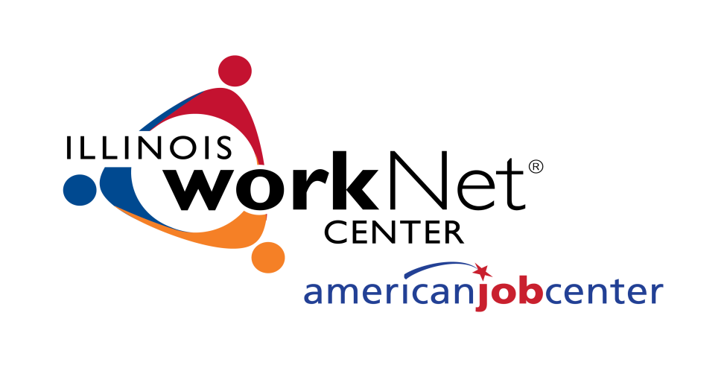

BUSINESS GRANTS FOR
EMPLOYEE TRAINING

PROGRAM OVERVIEW

Land of Lincoln Workforce Alliance
1300 South 9th Street
Springfield, Illinois (217) 558-4277

PURPOSE
The purpose of the Business Grants for Employee Training Program is to provide resources for employers to train currently employed workers in an effort to keep businesses and workers competitive.

Businesses must meet the following eligibility requirements to be considered for funding:
- Must have been in operation in Cass, Christian, Logan, Menard or Sangamon county for a minimum of six months prior to application for funding; and
- Must have at least one full-time employee; and
- Must demonstrate financial viability and must be current on all state, county, and local tax obligations; and
- Must comply with the non-discrimination and equal opportunity provisions of Section 188 of the Workforce Innovation and Opportunity Act of 2014; Title VI of the Civil Rights Act of 1964; Section 504 of the Rehabilitation Act of 1973 ; Age Discrimination Act of 1975; Title IX of the Education Amendments of 1972; and with 29 C.F.R. Part 37; and
- Must provide a match toward requested funding.

Priority is given to Cass, Christian, Logan, Menard or Sangamon businesses that offer marketable skills and self-sufficient wages.

Awards made in response to this application will be contingent upon availability of funds and released for the purposes authorized by this program.

Training needs to be completed by the contract end date unless otherwise authorized at time of grant approval.

Employers participating in the program are required to provide a match to the training costs as indicated below:
- 10 percent of the costs, for employers with 50 or fewer employees
- 25 percent of the costs, for employers with 51 to 100 employees
- 50 percent of the costs, for employers with 101 or more employees

The employer match may include the amount of the wages and benefits/fringes paid by the employer to a worker while the worker is attending training and may also include in-kind contributions.

Funding is provided on a reimbursable basis. Reimbursement for training will only be for successful completion of training.

ELIGIBLE APPLICANTS AND TRAINING ACTIVITIES
Businesses that are located in Cass, Christian, Logan, Menard or Sangamon county may be eligible for reimbursement of approved training costs if they:
- Are expanding their business enterprise in one of the above counties and/or
- Are training employees in skills necessary to enable the company to establish, maintain or expand into new markets and/or
- Are introducing more efficient technologies/continuous improvement systems into their operations which will result in greater output per employee, including quality certifications and/or
- Are providing additional training to employees who will be threatened with layoff and/or
- Are providing training that will result in benefits to employees such as: enhanced employability, job upgrades, increased wages, increased job security and/or
- Are providing job-linked training programs in response to new or changing technologies, processes, product lines, machinery or equipment being introduced in the workplace.

Employees must be full-time employees of the business. Part-time, seasonal or temporary agencies are not eligible to participate in the Incumbent Worker project.

Applications will be evaluated according to the following criteria:
- Project readiness (e.g. time schedule for project)
- Specific and measurable training objectives
- Level of value-added for the specific industry
- Quality and consistency of the proposed training programs
- Overall quality of application
- Cost is reasonable in relation to the type of training and number of workers

Applicants are limited to businesses with the targeted industry sectors listed below:
- Healthcare
- Transportation/Distribution/Logistics (TDL)
- Manufacturing
- Business Services and Finance
- Hospitality and Tourism
- Marketing and Sales

Industry sector exceptions will be considered on a case by case basis.

ALLOWABLE COSTS/ACTIVITIES
Reimbursement of employee training will allow for payment on the terms and conditions agreed to between the employer and Land of Lincoln Workforce Alliance through the execution of a contract. The employee skill requirements and training needs are established by the employer and may include basic, technical or managerial skill sets. Allowable costs may include:
- Tuition and school fees
- Books
- Training materials and supplies
- Vendor/contractor training costs
- Fees for technical or professional certifications
- Refresher courses for occupational certifications
- Training Room Fees

Note: Training wages while in training may be used to meet the employer’s match requirement but are not reimbursable costs under this program.

INELIGIBLE COSTS/ACTIVITIES
The program will not reimburse a company for training in the following areas:
- Self-paced learning
- “Outward bound” or experiential training programs.
- Personal development courses
- Non-skill related assessment
- Administrative costs
- Food or travel expenses for employees
- Safety, regulatory compliance training mandated for the workplace (ie OSHA)
- “Off the shelf” computer software training
- Other non-job related training
Additional the program will not reimburse for job design and analysis statements or activities (e.g. Work Keys), assessments of internal systems and other non-skill related assessments.

APPLICATION PROCESS
There is a two-step applications process
- Step One is the electronic submission of the Pre-Application Eligibility Questionnaire. Once the Land of Lincoln Workforce Alliance (LLWA) confirms eligibility, the applicant will be notified by email to proceed submitting the program application.
- Step Two is the electronic submission of a complete Employee Training Program Application and required attachments.

Receipt of an application does not commit the LLWA to award funding. The contents of an approved application will become part of the Contract. No costs incurred in the preparation and submission of an application is eligible for reimbursement.

Copies of the application can be downloaded from the LLWA website at: worknet20.org, click on News – Funding Opportunities or by e-mailing: BIZrep@worknet20.org,.

