BUSINESS GRANTS FOR EMPLOYEE TRAINING
Funding is available to help your company reduce training costs and make your employees more competitive!

- Address skill gaps in your current workforce
- Choose the technical training your workers need
- Boost productivity and/or avert layoffs

Businesses located in Cass, Christian, Logan, Menard or Sangamon County
and a business in one of the following industry sectors are eligible to apply:
.
Healthcare Manufacturing
Transportation, Distribution and Logistics
Marketing and Sales
Hospitality and Tourism Business and Finance
For Pre-application and program overview go to: www.worknet20.org
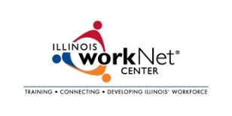
click on News-Funding Opportunity
Land of Lincoln Workforce Alliance, 1300 South Ninth Street Springfield, Illinois 62703 (217) 558-4277

